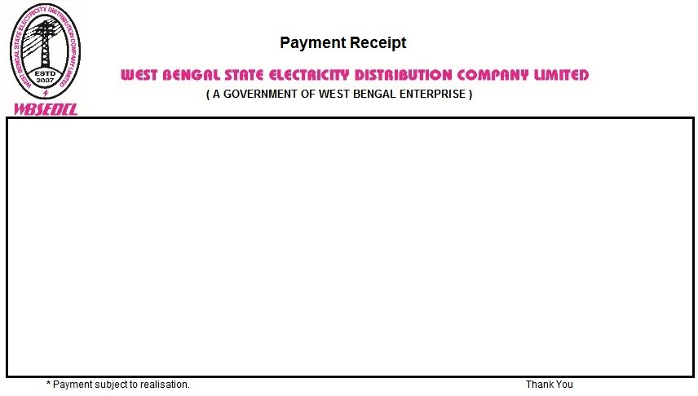

Transaction ID: ZIC52126754196 Date: 03.07.2024

Payment Gateway: BILLDESK

Billing Office: RANIGANJ CUSTOMER CARE CENTER

Consumer Id: 513076984 Name: RAJESH YADAV

Invoice Number /Appl. No. /Inst. No: 450013917798 Bill Paid For: AUG2024

Payment Mode : E-Payment Received: Rs. 1635